WEEK 4 – ORDER MANAGEMENT SYSTEM
1. Introduction
The Order Management System is the fourth module of the E-Commerce Database System. It continues the previous modules by connecting customers, orders, and products.
It stores order information, records the products and quantities in each order, calculates order totals, updates order status, and generates customer and sales reports.
Main Objectives
- Create and manage customer orders.
- Add multiple products to an order.
- Calculate the total amount of each order.
- Update order status to Pending, Shipped, Delivered, or Cancelled.
- Update quantities and remove cancelled orders.
- Generate customer history, product-wise reports, and sales analysis.
2. Existing Database
Database Name: Ecommerce_Product_DB
This module continues the database from previous weeks. It uses the existing Product table and adds Customer, Orders, and Order_Details tables.
Note: The SQL script assumes Product has Product_ID, Product_Name, and Price columns. Customer is created only if it does not already exist.
3. Orders Table Design
Column | Data Type | Constraint | Description
Order_ID | INT | Primary Key | Unique order number
Customer_ID | INT | NOT NULL, Foreign Key | Customer who placed the order
Order_Date | DATE | NOT NULL, DEFAULT | Date of order
Total_Amount | DECIMAL(10,2) | NOT NULL, CHECK | Total order value
Order_Status | VARCHAR(20) | NOT NULL, DEFAULT, CHECK | Current order status
Allowed statuses: Pending, Shipped, Delivered, and Cancelled.
4. Order_Details Table Design
Column | Data Type | Constraint | Description
Order_Detail_ID | INT | Primary Key | Unique order-line ID
Order_ID | INT | NOT NULL, Foreign Key | Related order
Product_ID | INT | NOT NULL, Foreign Key | Ordered product
Quantity | INT | NOT NULL, CHECK | Number of units ordered
Price | DECIMAL(10,2) | NOT NULL, CHECK | Unit price at order time
A UNIQUE constraint on (Order_ID, Product_ID) prevents the same product from being entered twice in one order. Quantity and price must be positive.
5. Updated ER Diagram
CUSTOMER (1) ───── (M) ORDERS
ORDERS (1) ───── (M) ORDER_DETAILS
PRODUCT (1) ───── (M) ORDER_DETAILS
Each customer can place many orders. Each order can contain multiple products. Each product can appear in many orders.
Relationship | Type
Customer → Orders | One-to-Many
Orders → Order_Details | One-to-Many
Product → Order_Details | One-to-Many
6. Sample Customer Data
Customer ID | Customer Name | Email | Phone | Address
2001 | Keerthi Stores | keerthi@example.com | 9000000001 | Thoothukudi
2002 | Arun Kumar | arun.kumar@example.com | 9000000002 | Tirunelveli
2003 | Priya S | priya.s@example.com | 9000000003 | Madurai
2004 | Rahul M | rahul.m@example.com | 9000000004 | Chennai
2005 | Divya R | divya.r@example.com | 9000000005 | Coimbatore
7. Sample Orders
Order ID | Customer ID | Order Date | Status
3001 | 2001 | 2026-10-01 | Pending
3002 | 2002 | 2026-10-02 | Shipped
3003 | 2003 | 2026-10-03 | Delivered
3004 | 2001 | 2026-10-05 | Delivered
3005 | 2004 | 2026-10-06 | Pending
3006 | 2005 | 2026-10-07 | Cancelled
Sample Order_Details
Detail ID | Order ID | Product ID | Quantity | Price
4001 | 3001 | 101 | 1 | 1999.00
4002 | 3001 | 102 | 2 | 2999.00
4003 | 3002 | 104 | 1 | 899.00
4004 | 3002 | 108 | 1 | 2499.00
4005 | 3003 | 112 | 2 | 650.00
4006 | 3003 | 113 | 1 | 750.00
4007 | 3004 | 106 | 3 | 599.00
4008 | 3004 | 114 | 2 | 349.00
4009 | 3005 | 111 | 1 | 1599.00
4010 | 3005 | 110 | 2 | 799.00
4011 | 3006 | 115 | 1 | 899.00
The SQL script calculates each order total by adding Quantity × Price for all details belonging to that order.
8. Order Management Operations
- Create an order by inserting a row into Orders with a valid Customer_ID.
- Add multiple products by inserting multiple rows into Order_Details with the same Order_ID.
- Calculate order totals using SUM(Quantity × Price).
- Update status using Pending, Shipped, Delivered, or Cancelled.
- Update quantities in Order_Details and recalculate the order total.
- Delete cancelled orders using the provided DELETE query when ready. ON DELETE CASCADE removes their order-detail rows.
9. Customer Order History and Purchase Analysis
Report | Purpose
Customer order history | Lists customer orders, dates, statuses, and totals
Product-wise order report | Shows order count, quantity sold, and sales per product
Times each product was ordered | Counts distinct non-cancelled orders containing each product
Total quantity sold | Adds quantities in non-cancelled orders
Customer with maximum orders | Finds customer(s) with the highest non-cancelled order count
Total spending by customer | Sums each customer's non-cancelled order amounts
Average order value | Calculates the average total for non-cancelled orders
Total sales amount | Adds totals for non-cancelled orders
10. Constraints Used
- PRIMARY KEY uniquely identifies every row.
- FOREIGN KEY connects Orders to Customer, Order_Details to Orders, and Order_Details to Product.
- NOT NULL requires essential values.
- UNIQUE prevents duplicate customer email/phone and duplicate product lines in one order.
- CHECK prevents negative totals, non-positive quantities/prices, and unsupported statuses.
11. Query Output Screenshots
Run the SQL queries in MySQL Workbench and insert the original screenshots of these result grids:
- Customer table
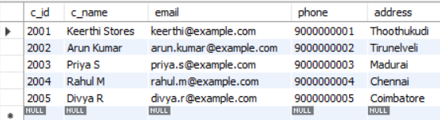
- Orders table
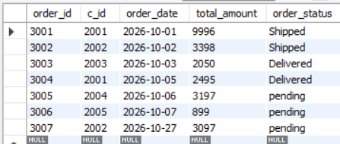
- Order_Details table
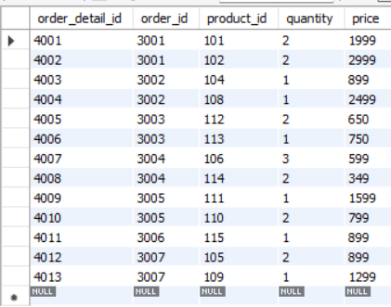
- Customer order history
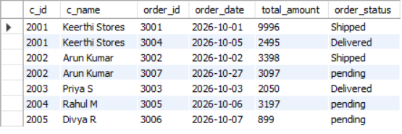
- Product-wise order report
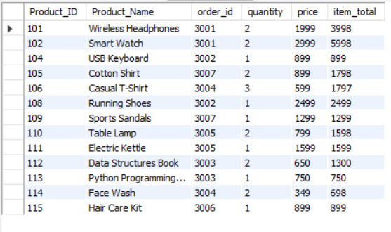
- Number of times each product was ordered
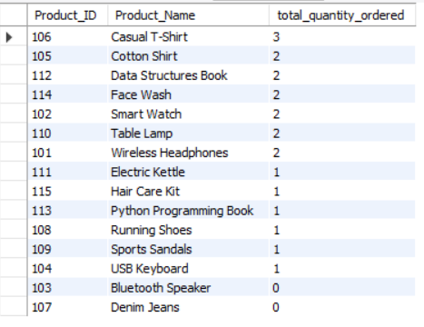
- Total quantity sold
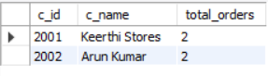
- Customer(s) with maximum number of orders
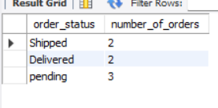
- Total spending by each customer

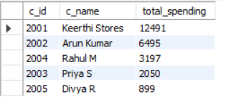

- Average order value
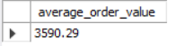
- Total sales amount

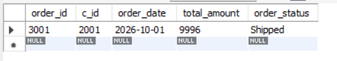
12. Conclusion
The Order Management System extends the e-commerce database by recording customer orders and the products included in each order. Primary keys, foreign keys, NOT NULL, UNIQUE, and CHECK constraints help maintain data integrity. SQL operations are used to create orders, calculate totals, update statuses and quantities, and generate customer and sales reports.

